Dustin Watson

Seat # 10

CNA 397

LAB 8

Due Feb 27

Part 1:

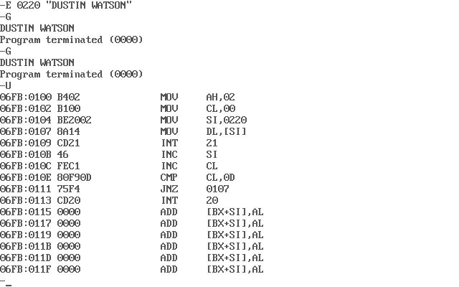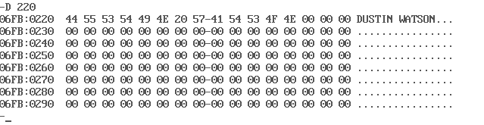

Part 2:

